# ICE 7 – Classes (Animal Shelter)

## Part 2 – Initial Screen

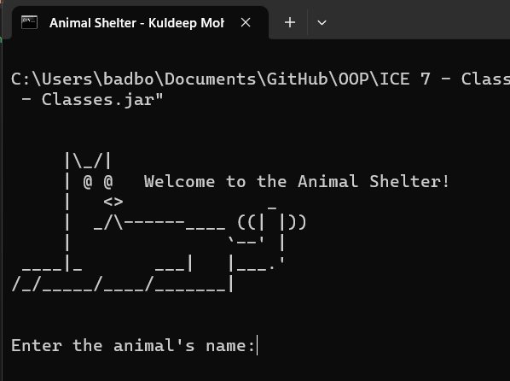**Screenshot 1**

Context: As the application loads up (AnimalShelter.jar), it presents the banner message as a greeting message and prompts the user with their first animal’s name to enter.

## User has entered details for the first animal as prompted.Part 3 – Input Screen

**Screenshot 2**

Context: After the user successfully enters data to input, the user is printed a message saying that the App had successfully recorded the animal’s name.

## Part 3 – Input Screen

**Screenshot 3**

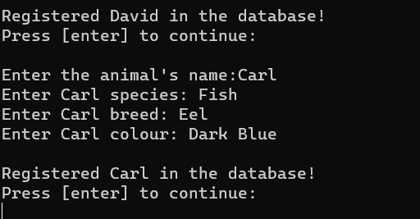

Context: User had entered the Second Animal (Carl)’s information was successfully entered and recorded into the application.

## Part 3 – Input Screen

**Screenshot 4**

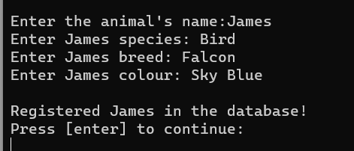

Context: User had entered the Third Animal (James)’s information was successfully entered and recorded into the application.

# Part 5 – Output Screen

**Screenshot 5 – showing output screen**

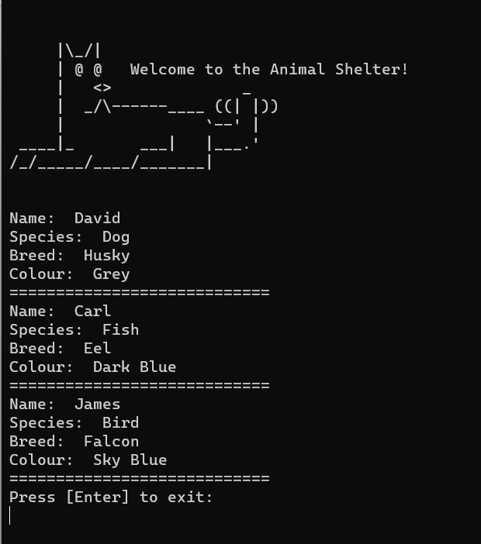

**Context:** The recorded animal names are printed out to the user after they have successfully entered 3 animal names as per the application’s design.

# Part 5 – Questions

**Question 1 – What are classes?**

Classes are blueprints or templates that enable the creation of "objects". They set the foundation for pre-defined attributes and methods that can be used throughout a program to manipulate and process data. They are used to create objects and specify their purpose, behavior, etc. Using classes effectively aids in reusing code, reducing overall maintenance, as well as creating opportunities for object-oriented concepts like inheritance and polymorphism.

**Question 2 – What are objects?**

An object builds on the capabilities of classes by using the attributes given to the class and building its unique data and methods. It is a unique part of object-oriented programming as it can be manipulated and utilized in a multitude of ways as a program may need. Using objects effectively can help support code reusability as well as improve the overall modulation of programs. This, in turn, creates a simpler environment to work with.

**Question 3 – If I want to create 3 animal objects (dog, cat, chicken), do I need to write 3 classes?**

Using concepts learned in class like "class" and "objects", it becomes straightforward to create a single class file (i.e., "animal) that creates the blueprint for these 3 animal objects and lets the user specify the attributes (i.e., name, species, etc.). Therefore, to answer the question, no, the programmer can simply create a single class and define the attributes and methods for the "animal" instance to use.

**Question 4 – What is a constructor method?**

A constructor method is used to initialize an object of a class during the creation process. It uses the same name as the class and is ideally declared publicly to allow global access throughout the program. The method will have pre-defined parameters that can take in data like a name, age, etc. to create a new object with the entered attributes.

**Question 5 – What does a constructor method return?**

Since the constructor method's purpose is to create the object, its return value will always be simply the object it is creating. Since the method is used to initialize and create the attributes of a new object, the constructor method will return the prepared object.